Session 1 answers

3.10 Answers

Question 1
# Either
odds <- c(1,3,5,7,9)

# Or
odds <- seq(1,9,2)

# Then
evens <- odds + 1

Question 2
exercise_counts <- c(100, 233, 41, 232, 656, 12, 92)

mean(exercise_counts)
[1] 195.1429
The first chunk does not give any errors, it correctly calculates the mean of the given vector of numbers.
exercise_counts <- c(100, 233, 41, 232, "656", 12, 92)

mean(exercise_counts)
Warning in mean.default(exercise_counts): argument is not numeric or logical:
returning NA
[1] NA
The second chunk doesn’t give an error, but a warning. It clearly hasn’t returned the result we wanted. The reason for this is that our vector of numbers contains a variable of the character type, which is not numeric. This has changed the whole vector into a character vector. The mean() function requires either numeric or logical inputs, and as soon as a single input is not either of those, it returns NA. (As an aside, you might try replacing “656” with FALSE, and see what happens…and have a think why!)
exercise_counts <- c(100, 233, 41, 232, 656, 12, 92)

mean(exercise_count)
Error:
! object 'exercise_count' not found
This third chunk does give an error. This is a classic example of R taking us literally—we have a typo in the mean() function where we have asked it to take the mean of an object that doesn’t exist (missing an ‘s’ from the name). R doesn’t know that it was just a typo and won’t fix it for us.

Question 3
exercise_counts <- c(100, 233, 41, 232, 656, 12, 92)

my_median <- median(exercise_counts)

my_variance <- var(exercise_counts)

my_SD <- sd(exercise_counts)

# Look at the objects you've created
my_median
[1] 100
my_variance
[1] 48695.48
my_SD
[1] 220.6705

Question 4
new_vector <- c(141, 61, 883, 548, 981, NA, 23)

mean(new_vector)
[1] NA
This is similar to what happens if there is the wrong variable type for the mean() function to work. Any NAs in the input lead to the output just being NA, because R cannot determine the mean of a vector if there is a missing value.

Question 5
mean(new_vector, na.rm = TRUE)
[1] 439.5
The na.rm argument allows the NA value to be ignored when calculating the mean. It isn’t a “one-size-fits-all” fix though. It is still important to have a strategy for identifying and handling missing values in data.

5.8 Answers

Question 1
results |>
ggplot(aes(x = log2FoldChange)) +
geom_histogram(bins = 100) +
labs(
x = "log2 fold change (TBI vs sham)",
y = "Number of genes"
) +
theme_minimal()
Warning: Removed 9715 rows containing non-finite outside the scale range
(`stat_bin()`).
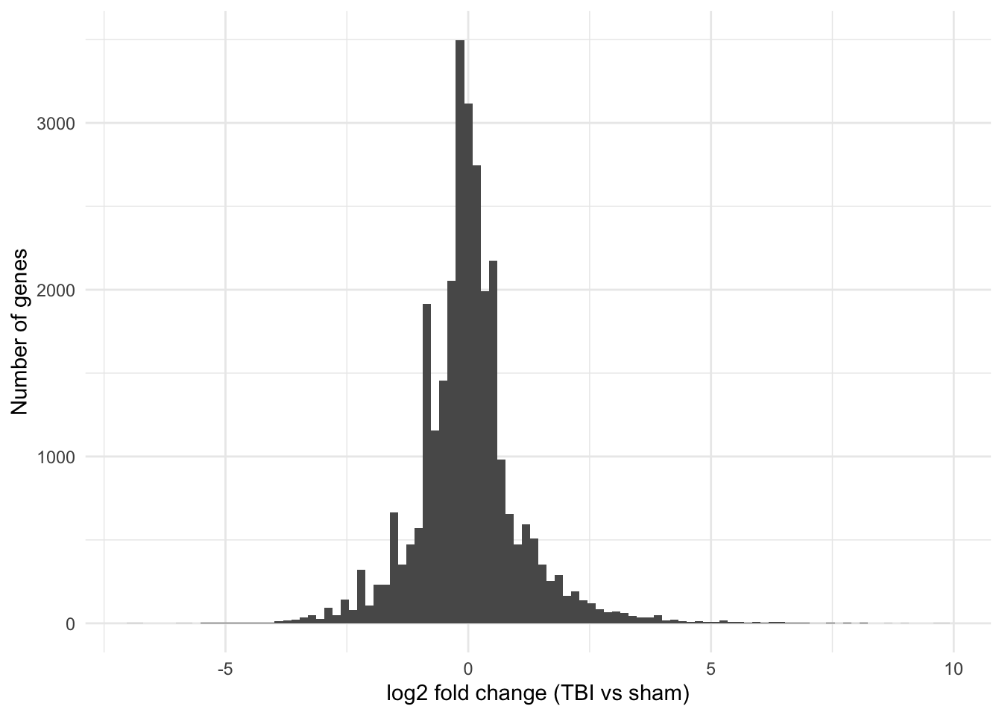
A tall symmetrical peak centred on zero, with long thin tails. Most genes don’t change at all—which is exactly what you should expect, and what the boxplot in Plot 3 was telling you. The interesting biology lives in those tails.

Question 2
results <- results |>
mutate(
significant = !is.na(padj) & padj < 0.05 & abs(log2FoldChange) > 1
)
Then the plot code should work without changing anything:
Warning: Removed 18592 rows containing missing values or values outside the scale range
(`geom_point()`).
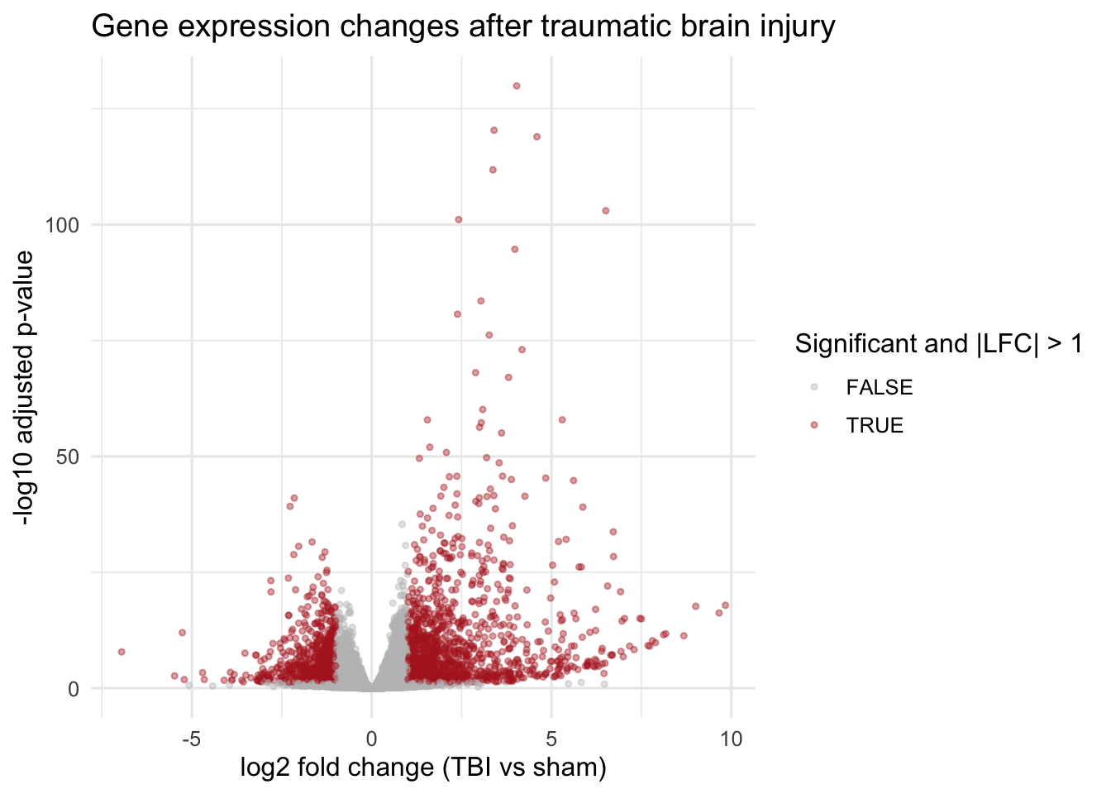

Question 3
# overwrite our volcano object with some more geoms
newvolcano <- newvolcano +
geom_hline(yintercept = -log10(0.05),
linetype = "dashed",
colour = "black") +
geom_vline(xintercept = c(-1, 1),
linetype = "dashed",
colour = "black") # notice here we create a vector of x intercepts using c() so that we can have more than one x intercept

# look at the plot
newvolcano
Warning: Removed 18592 rows containing missing values or values outside the scale range
(`geom_point()`).


